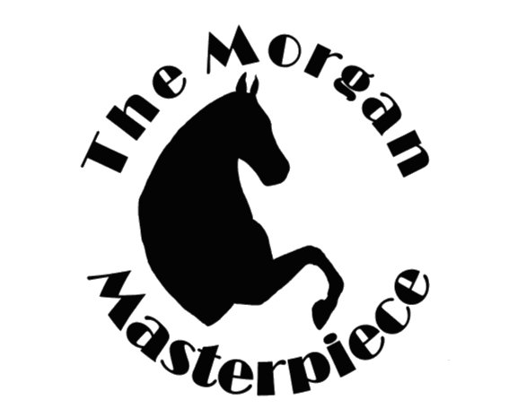
The Morgan Masterpiece
Charity Horse Show
Held at the Sunnyview Expo Center in Oshkosh, WI Show dates are July 15,16,17 2021

Benefiting
Rawhide Youth Services
New London, WI
The Rawhide Youth Services has been our charity for 16 years, donating approximately $54,750.00 over the show’s lifetime, and $13,000.00 over the past 3 years. Rawhide is a facility which works with young men between the ages of 13 and 17. These young men are referred to Rawhide by a Social Service Agency or a Juvenile Judge. Rawhide provides academic and vocational training in preparation for college, independent living or returning to their families. The Rawhide Youth Services is very involved in helping our show run smoothly, from opening gates, handing out awards, cleaning the barns and distributing bedding. Their help is very much appreciated. When you see the boys at the show please give them a personal Thank You.

SPONSORSHIP LEVELS
Woodbury  $50.00 | Ethan Allen  $80.00 | Bulrush  $100.00 | Sherman  $150.00 | Black Hawk  Championship sponsor  $250.00 | Justin Morgan  Championship Sponsor  $500.00
Sponsor's will be recognized during the show with sponsors for each session being announced, signage displayed at the show and a listing on the Morgan Masterpiece website.

Thank you for Supporting the Morgan Masterpiece, your generosity is what keeps this fun horse show continuing!!
Name ________________________________________________________Phone #________________________
Address______________________________________________________________________________________
City, State, Zip_________________________________________________ Email:___________________________
Class to sponsor (optional)________________________________________________________________________
Additional information for announcements:__________________________________________________________
______________________________________________________________________________________________
______________________________________________________________________________________________
Amount enclosed_________________________
Please make all checks payable to: Morgan Masterpiece
Payment: _____Check enclosed _________Visa _________MasterCard

Card Number ___________________________________Expiration date____________ sec. code__________

Signature _________________________________________________________________________
Send payment to: Laurie Freitag
1805 Cty Hwy E
Blue Mounds, WI 53517
OR use the Paypal tab on the website. ** If you prefer to pay via credit card please provide a valid email address. You will receive an electronic invoice from Laurie Freitag, Treasurer of Morgan Masterpiece, via Paypal. You can pay via the invoice link with your credit card of choice. You will also receive a receipt of your donation once you enter your card and it processes.

www.morganmasterpiece.com
Morgan Masterpiece Tax ID: 39-1951995 a 501-c charitable organization
Please keep a copy for your records

