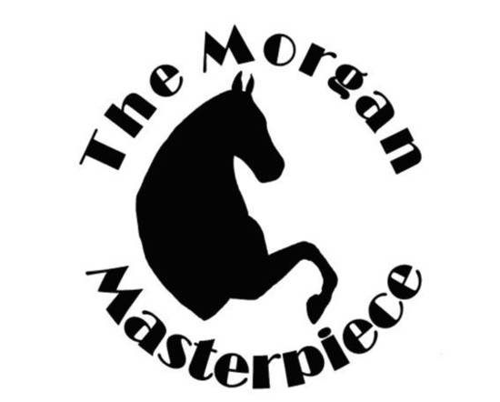
The Morgan Masterpiece
Charity Horse Show

Benefitting the Rawhide Youth Services, New London, WI

The Morgan Masterpiece Charity Show is a class A rated show. Since 1999, our show has been held annually in July at the Sunnyview Expo Center in Oshkosh, WI. The Rawhide Youth Services has been our charity benefit for over 16 years and we have been able to donate over $54,750.00 to them throughout.
Rawhide Youth Services is a facility that works with teens and young adults struggling with mental health, emotional and behavioral difficulties. By using a relationship-based approach to treatment, care and education, Rawhide can provide them academic and vocational training in preparation for college, independent living or returning to their families. An equine program has also been incorporated into their therapy options. Managing therapeutic horses teaches youth how to build relationships and overcome their issues and trauma in a non-threatening environment.
Rawhide Youth Service is involved in helping our show run smoothly by helping with various tasks. They assisted with distributing stall bedding, opening the arena gates for the show classes, awards presentation and barn clean up. Their help is very much appreciated.
Silent Auction Donation Requests
A silent auction fundraiser held at the show helps raise money needed for show expenses and the Rawhide Youth Services benefit. The show committee is asking for your help by donating items or services which will be bid on by anyone at the show. Auction will conclude on Saturday and the winning bidders can then purchase and pick up items they won.
A wide variety of items either new, gently used or even vintage and of course anything horse related would be graciously accepted. Item ideas are travel related such as weekend getaways, experiences like spa day or local brewery tours or event tickets. Sports tickets and memorabilia have been good sales. Activates passes for golf, skiing, or yoga classes are great. Music is enjoyed so perhaps concert tickets, backstage passes or lessons can be given. Food-related items make an appearance most silent auction. Gift baskets, cooking classes and restaurant gift certifies are welcome donation.

Sincere thanks for your help from the Morgan Masterpiece Charity Horse Show Committee
Silent auction contact: Sally Clark, N3903 Firelane, White Lake, WI 54491 smclark408@yahoo.com

Donating not only helps us, it is good for you too.
It provides great advertising for your business or service that is tax deductible too!
MORGAN MASTERPIECE IS A 501-C CHARITABLE ORGANIZATION
TAX ID: 39-1951995

